1. There are ten entities contained in the table. The employee is the entity set. Each entity has five attributes: EMP_NUM, EMP_LNAME, EMP_INIT, EMP_FNAME, DEPT_CODE and JOB_CODE. EMP_NUM is the primary key. Each entity is classified by a unique number. JOB_CODE and DEPT_CODE are the foreign keys. It can be assumed that they are linked to other tables with department and job descriptions.
2. The DIRECTOR table’s primary key is DIR_NUM. The PLAY table’s primary key is PLAY_CODE.
3. The PLAY table’s foreign key is DIR_NUM.
4. 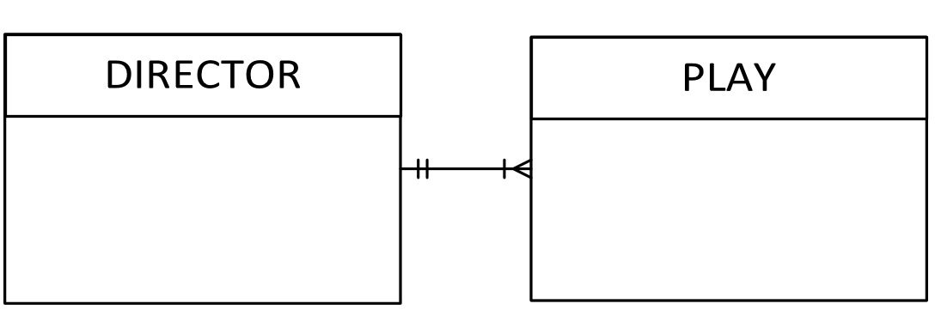
5. 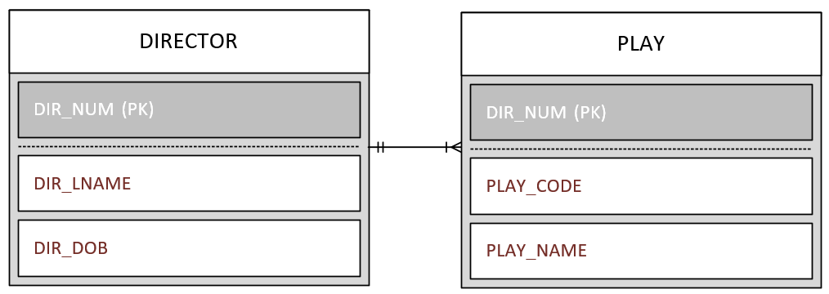
6. The PLAY table would be the basis for the INDEX table. The index key would be DIR_NUM.
7. 